Introduction to snapping turtles by Stan Gielewski

In the wild

There are two groups of the snapping turtles – common snapping turtles and alligator snapping turtles. Common snapping turtles have four subspecies: Common Northern snapping turtle (Chelydra serpentina serpentina), Florida snapping turtle (Chelydra serpentina osceola), Mexican snapping turtle (Chelydra serpentina rossignoni) and Ecuadorian snapping turtle (Chelydra serpentina acutirostris). There is only one turtle in the second group – the alligator snapping turtle (Macroclemys temmincki).

Photo: Common snapping turtle (left) and alligator snapping turtle (right)

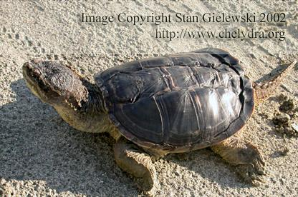 | 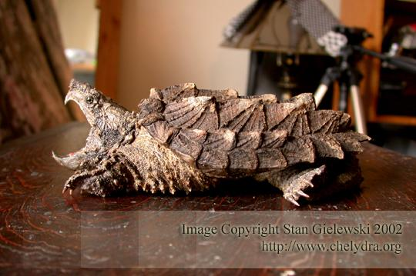

Snapping turtles live in lakes, ponds and rivers of Eastern and Southern North America, Central America and Northern part of South America. Sometimes they can also be found in brackish waters, like in Florida for example.

Common snappers are one of the largest turtles in North America. They can reach even 60 pounds and live 40-50 years. The alligator snapping turtles can grow to over 250 pounds and as a slow growing species, live much longer.

In the wild, snapping turtles eat a variety of fish, snails, worms, birds (fowl, ducks), mice or other small mammals that happen to fall in the water. They also consume all sorts of vegetation. Snapping turtles are known for their prehistoric look. They have long and spiky tails. Necks of the common snappers are very long and they can reach very far. On the other hand, alligator snapping turtles have short necks and are easier to handle.

Snappers are very strong, especially their legs and jaws. A large adult snapper can inflict serious injury, and they should always be handled with caution. They should never be picked up by their tail, especially the larger adults. Common snapping turtles are famous for their ferociousness, but they are not aggressive by nature. Their quick as a lightning ‘snap’ is only how catch their pray. It is also part of their defense mechanism – they will try to bite when threatened. Saying this, snappers are in fact rather shy animals and will always try to avoid confrontations. They always prefer to turn around and walk or swim away. Snapping turtles never chase after people!

The alligator snappers look more like a dinosaur than a turtle. While adult common snappers have their shells almost sooth, shells of the alligator snapping turtle have clearly visible three ridges. Another distinctive feature that this species possesses is the reddish fleshy worm-like lure at the bottom of its mouth. Lying still at the bottom with its mouth wide open, the alligator snapper wiggles the lure to attract fish. When a fish enters its mouth to investigate he wiggly worm, the turtle slams the jaws closed and swallows it.
Being much larger than the common snappers, they have much more powerful jaws. They are the largest North American freshwater turtles. They can easily amputate a person’s fingers.

In captivity

Since snapping turtles grow to large sizes, a serious thought should be given before making the decision of acquiring a snapping turtle. They will eventually require a very large tank or even a pond.

For those who decide on caring for snapping turtles as pets (many snappers end up at our homes as a result of rescue or adoption), the tank should be large enough so the turtle can freely move in it.

Clean water should be deep enough to cover the snapper but not too deep so while sitting at the bottom the turtle will be able to reach the surface for breathing. The water should always be clean (use a powerful external filter) and warm (heated with a submersible heater with a thermostat). The temperature should be kept at around 22-25 C all year round. Snappers kept in captivity, unless housed outdoors, don’t require hibernation.

Decoration in the tank should be kept to minimum. A large tank or a pond could be transformed into a beautiful display (examples can be seen in some Zoo’s), but it cost a lot of money and needs a lot of space. An addition of inch deep layer of gravel at the bottom would be nice, but is not crucial. A large heavy stone and a heavy, stabilized piece of driftwood should be placed inside to give the turtle a chance to rest and climb out of the water. Many keepers have been successful in caring for snappers for years in a virtually empty tank filled with water only. It is much easier to create attractive and elaborate setups for baby snappers. The challenge starts as the turtles grow.

Snappers should be exposed to a day-night cycle and have a light source suspended above the water during the day. Many people suggest that a basking light is not necessary for snappers, but in my opinion such is a good addition - my snappers, especially when they were young, are regular baskers.

Snapping turtles should not be fed in excess. Overfeeding leads to obesity which is not healthy. Small snapping turtles should be fed once every 2-3 days, and larger turtles once a week should be fine. They will eat a wide variety of foods. They will thrive on raw beef, fish, liver and hearts. Live food should be given as a supplement only. If live food is not available, use whole frozen fish. The turtle should swallow food whole with bones and heads. Also, commercially available snack turtle food is always a good vitamin and mineral supplement.

It is a good idea to take your snapper for ‘a walk’ on sunny days - it helps them produce vital for reptiles Vitamin D3. It is a lot of fun to observe your turtle explore the surroundings. Common snappers are very curious creatures with lots of character. One reminder though - don’t let them out of your sight!

Many snappers become tame with age. People find them to be quite easy to keep. The only problem is with their size and being aggressive. For these reasons, they are not a good pet for a child. On the other hand, for an adult person, with proper care they can be transformed into easy going and great pets. These turtles are very hardy and will eat a lot. Just remember – snapping turtles will grow in size to over 60 pounds!

Read More

To read more about the life and captive care of snapping turtles please visit the Snapping Turtle Page at http://www.chelydra.org

This text is free to distribute for personal non-commercial use.
Text & Images © Copyright Stan Gielewski/Chelydra.Org 2003-2006, All Rights Reserved

_______________________________________________________________________

Dear Reader,

If you find this article and the information at Chelydra.Org useful, please take a moment to support us with a PayPal donation.

To make your donation please CLICK HERE

Thank you very much!
Webmaster, Chelydra.Org

